Practical 6 Questions

Q1. How to create multi-dimensional array in java?

* Int a[][] = new int [x][y];
* Int a[][] = new int[4][];

Int a[0] = new int[5];

Int a[1] = new int[5];

Int a[2] = new int[5];

Int a[3] = new int[5];

* Int a[][] = {{1,2,3,4},{10,20,30,40},{11,12,13,14}};
* Int [][]a = new int [4][5]

Q2. How to initialize and display multi-dimensional array elements in java?

* Int a[][] = {{1,2,3,4},{10,20,30,40},{11,12,13,14}};
* Initialization can also be done using 2 for loops
* Display of 2D array can be done using 2 for loops

Q3. How to perform mathematical operations on 2D array on matrix?

* Use 2 for loops and then apply the mathematical condition on each element

Q4. What is a wrapper class? How are wrapper classes useful?

* A wrapper class is a class whose object wraps/contains primitive data types
* They convert primitive data types to objects
* The classes in java.util package handles only objects and hence wrapper class help in this case also

Q5. What are inbuilt methods and constructors in String class?

* Methods
  + Obj1.equals(obj2) -> gives Boolean value
  + String x = “hello”;

String y = x.substring(2);

String z = x.substring(2,5);

* + S1.equalsIgnoreCase(s2);
  + S1.length();
  + S2 = s1.toLowerCase
  + S2 = s1.toUpperCase
  + S1.compareTo(s2) -> -ve if s1<s2, +ve if s1>s2, 0 if s1 =s2
  + S1.concat(s2) -> concatenates s1 and s2
  + S2 = s1.replace(‘a’,’b’) -> replace all appearances of a by b
* String constructors

1. Char a[] = {‘P’,’I’,’C’,’T’};

String s = new String(a);

1. Char a[] = {‘P’,’I’,’C’,’T’};

String s = new String(a,1,3);

1. Byte a[] = {65,66,67,68};

String s = new String(a);

1. Byte a[] = {65,66,67,68};

String s = new String(a,1,3);

Q6. How does the String class differ from String Buffer and String Builder class?

* StringBuilder in Java represents a mutable sequence of characters.
* String Class in Java creates an immutable sequence of characters, the StringBuilder class provides

an alternative to String Class, as it creates a mutable sequence of characters.

* The function of StringBuilder is very much similar to the StringBuffer class, as both provide an

alternative to String Class by making a mutable sequence of characters.

* StringBuilder class differs from the StringBuffer class on the basis of synchronization. The

StringBuilder class provides no guarantee of synchronization whereas the StringBuffer class does.

* StringBuilder is faster than StringBuffer.

Q7. What are the inbuilt constructors and methods present in String Buffer and String Builder class?

* String Buffer constructors
  + 1) StringBuffer():- It reserves room for 16 characters without reallocation

e.g. StringBuffer s =new StringBuffer();

* + 2) StringBuffer(int size):- Allocates Accepts an integer argument that explicitly sets the size

of the buffer

e.g. StringBuffer s =new StringBuffer(20);

* + 3) StringBuffer(String str):- :- It accepts a string argument that sets the initial contents of the

StringBuffer object and reserves room for 16 more characters without reallocation.

e.g. StringBuffer s=new StringBuffer(“PICT”);

* 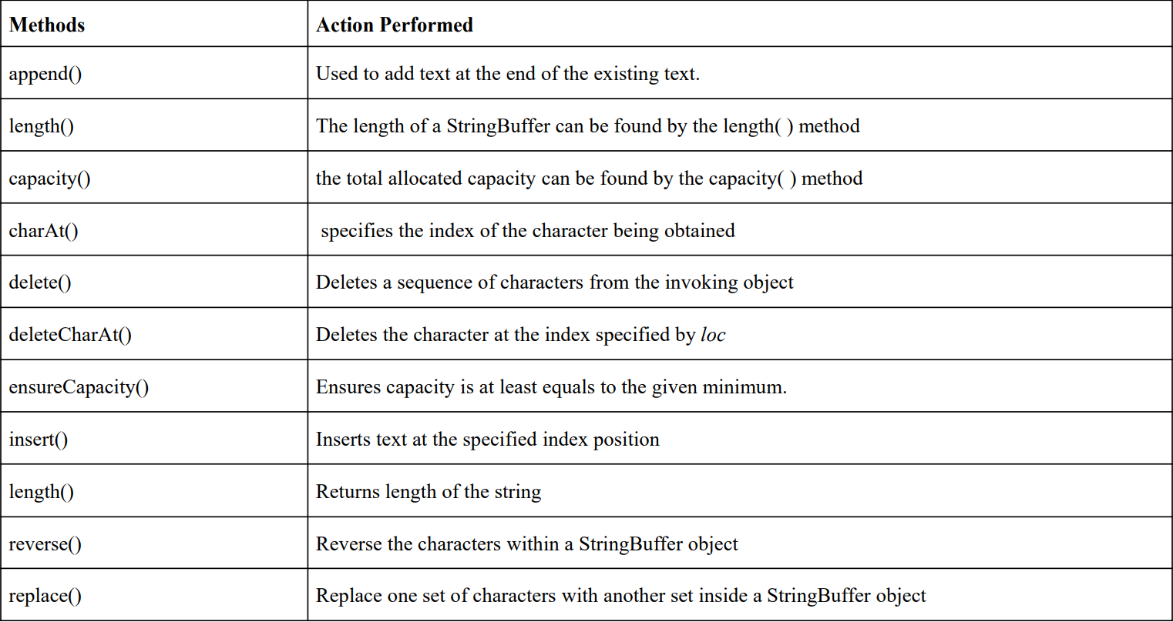String Buffer Methods
* StringBuilder constructor
  + StringBuilder() -> It creates an empty StringBuilder with the initial capacity of 16
  + StringBuilder(String str) -> It creates a String Builder with the specified string
  + StringBuilder(int length) -> It creates an empty StringBuilder with the specified capacity as the length
* StringBuilder Methods
  + Append(String s)
  + Insert (int x, String s)
  + Replace (int startindex, int endindex, String str)
  + Delete (int startindex, int endindex)
  + Reverse()
  + Int capacity() -> used to return current capacity
  + ensureCapacity (int minimumcpacity)
  + char charAt (int index)
  + int length()
  + String substring (int beginindex)
  + String substring (int beginindex, int endindex)

Q8. What is a vector in Java?

* 1. It is found in java.util package extends AbstractList and implements the List interface
* 2. Vector implements a dynamic array which means it can grow or shrink as required
* 3. They are very similar to ArrayList, but vector is synchronized and has some legacy methods that the collection framework does not contain

Q9. How to use vectors to store a list of objects that may vary in size?

Import java.util.\*;

Public class main{

Public static void main (String args[]){

Vector <String> v = new Vector <String>();

v.add(“Tiger”);

v.addElement(“Cat”);

System.out.println(vec);

}

O/P: [Tiger, Cat]

Q10. What is autoboxing and unboxing in java? Explain with example?

* Autoboxing: Automatic conversion of primitive types to the object of their corresponding wrapper classes is known as autoboxing.
* For example – conversion of int to Integer, long to Long, double to Double etc.
* Unboxing: It is just the reverse process of autoboxing. Automatically converting an object of a wrapper class to its corresponding primitive type is known as unboxing.
* For example – conversion of Integer to int, Long to long, Double to double, etc.